**Understanding the Basic Transformations: Rotation and Reflection**

Have you ever wondered how graphic editing apps like Photoshop performed basic image editing like rotation and flipping? The underlying principles behind this are transformations. All complicated image editing, scaling, and mapping applied in real-life applications extend from a basic understanding of simple transformations like rotations, reflections, dilation, etc. In this article let’s explore how each of these transformations works, and how to transform basic shapes.

**Types of Transformations**

Transformations can be broadly classified into four main types: translation, rotation, reflection, and dilation. The scope of this article is rotation and reflection.

**Rotation**

Rotation is a transformation that alters the orientation of a shape or object. Real-life activities like turning a steering wheel to change the direction of a moving car, rotating a door knob, or tightening a screw, all involve rotation.

To describe a specific rotation we need to define the following:

* The amount of rotation - Several ways can be used to define this, in day-to-day life we describe it using turns, such as full turn, half turn, quarter turn, etc., in geometry, the angle of rotation is used as it is more precise.
* The center of rotation - The point about which the shape/object must be rotated.
* The sense - Whether it is a clockwise or anti-clockwise rotation.

To perform a rotation on paper you can follow the simple steps below. Let’s try to rotate the image given in the diagram below about the origin (0,0), by an angle 90° anti-clockwise.

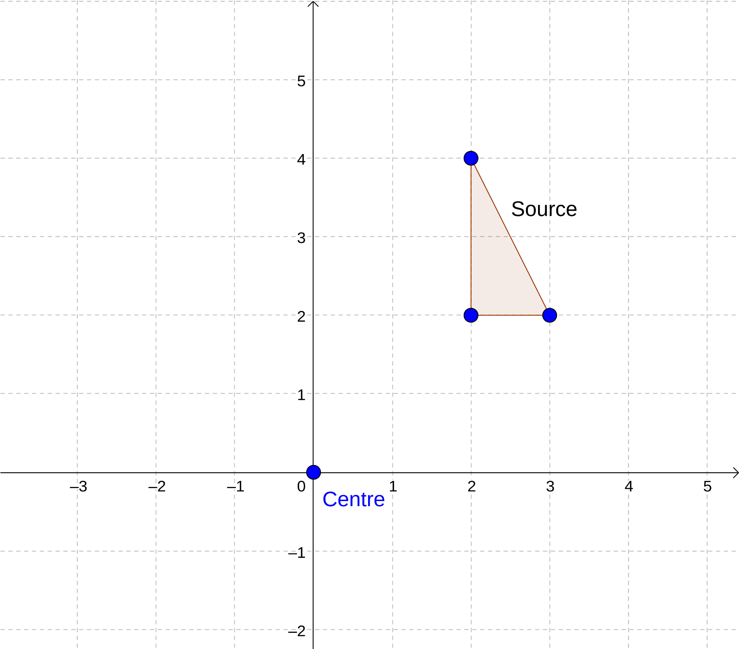

Step 1: Indicate the 90° angle using a protractor from a chosen vertex of the source as illustrated below.

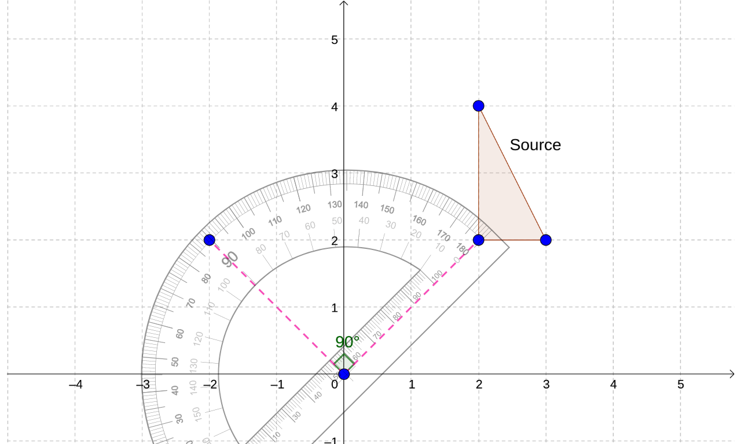

Step 2: Trace the source onto a tracing paper.

Step 3: Hold down the tracing paper with a pencil on the center of rotation.

Step 4: Rotate the tracing paper (anticlockwise) and copy the image.

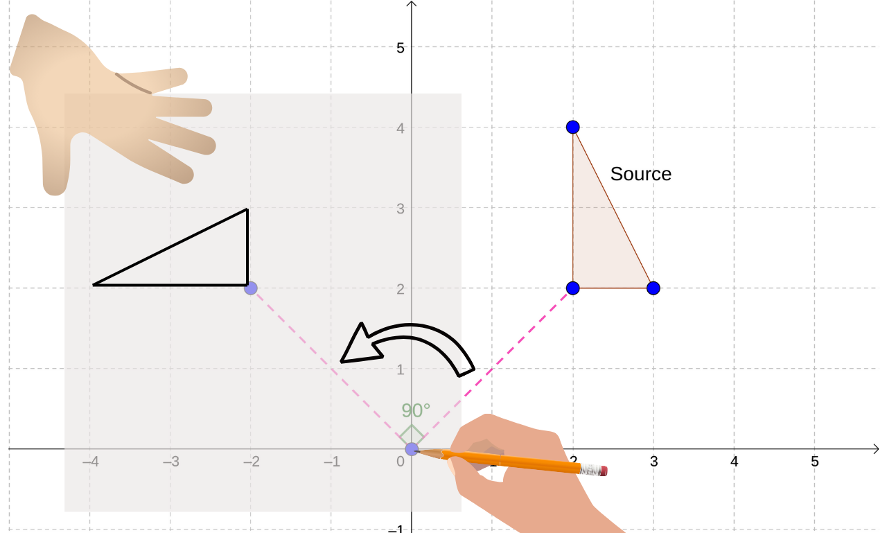

**Reflection**

Reflection, also known as a flip, mirrors a figure over a specified line called the line of reflection. The image created is a mirror image of the original figure.

To describe a specific rotation we need to define the following:

* The mirror line - On a cartesian plane, a line is defined by a linear equation which can be generalized into the format y = mx + c.

Example: Reflecting a letter 'L' over the y-axis on a Cartesian plane results in a backward 'L'. The size and shape of the letter remain unchanged.

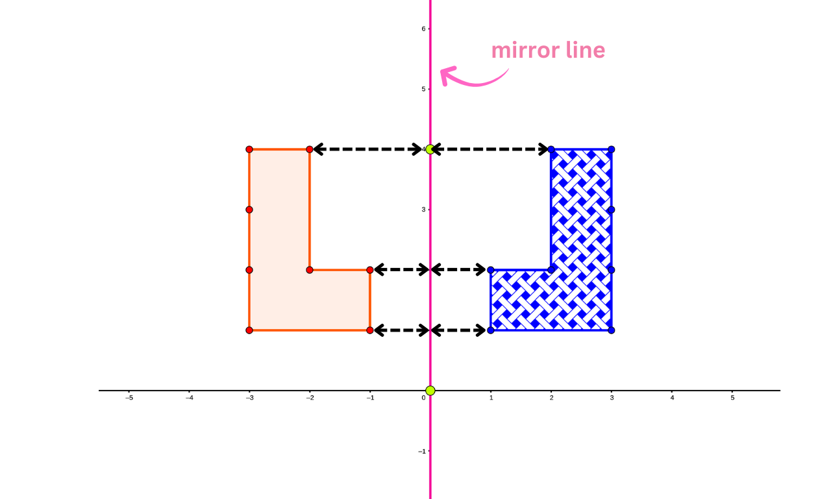

Every point in the image is the same distance from the line of reflection as their corresponding points in the source.

Example #2 : The following shows a reflection along the mirror line of equation y = 3x + 1

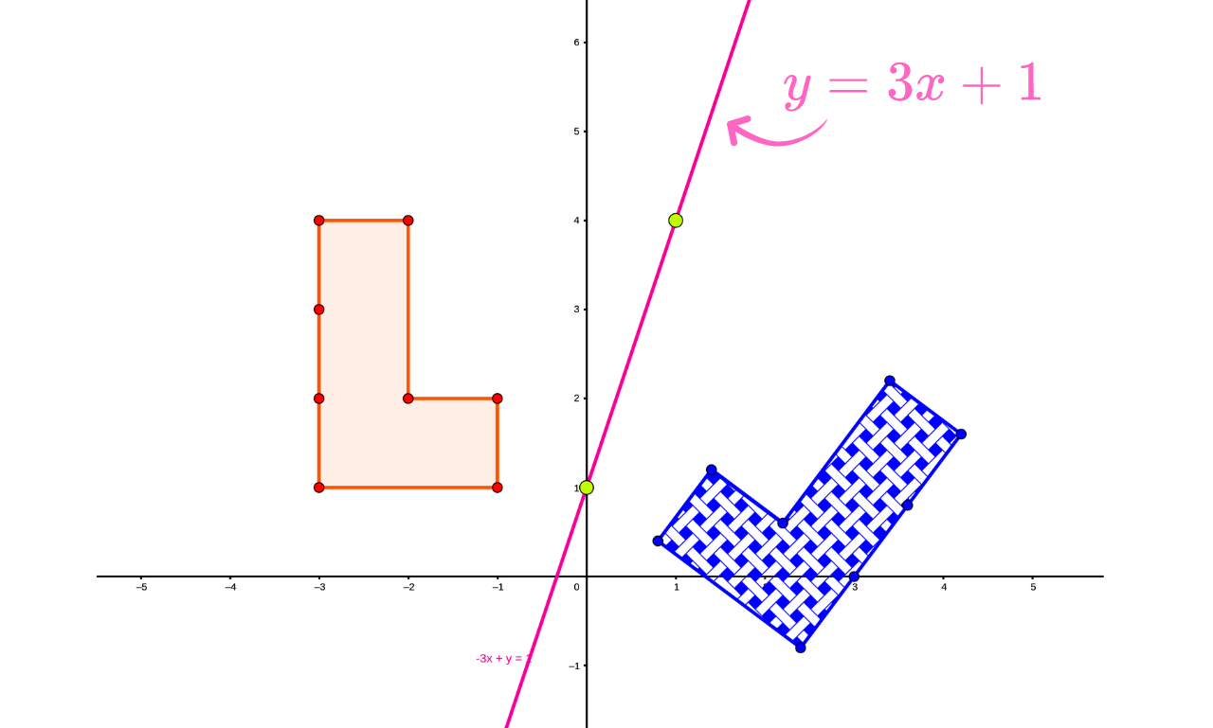

**Mathematical Properties of Rotation and Reflection**

Transformations exhibit certain mathematical properties:

Isometry: Both rotations and reflections, are isometries. This means they preserve distances and angles, keeping the original shape and size intact.

Orientation: Reflections and rotation change the orientation of an image.